Saxion Data Management Plan (DMP) template (version 05-2021)
Please read the Saxion Guidelines for Research Data Management and the Saxion Data Re-Use Protocol.
General Information
Research-ID | Generated when registered in RIS (https://srs.saxion.nl/post-it/)
Title Project
Funder (if relevant)
Grant Reference Number (if relevant)
Research Group(s)
(ass.) Lector ultimately responsible
Principal Investigator (PI)
ORCID PI
Date of First Version
Data of Last Update
Have you sought advice from a data steward from Saxion Research Services to fill this DMP in?
Data Collection
Have you explored reusing already existing data?
Are there reasons for not reusing already existing data?
How will the provenance of reused data be documented? | Think about persistent identifiers, for example a DOI.
If you are reusing data, are there any constraints on the reuse of this data? | Keep the reuse license in mind.
Details on the kind of data that will be collected or produced | What type, format and volume?
Which methods will you use if new data are collected or produced?
Data Quality and Documentation
Indicate how your data will be organized during the project. | What is your initial folder structure?  How do you handle version control?  Think about how you plan to control and to document the consistency and quality of your data collection.  Examples for organizing files and folders: https://www.wur.nl/en/Value-Creation-Cooperation/Collaborating-with-WUR-1/Organising-files-and-folders.htm *
What metadata standards will you be using? | The metadata standard used by Saxion is CERIF. Use community metadata standards where these are in place.
Are you planning to make your data available for reuse?
How do you plan to document information that enables re-use of your data? | Indicate which metadata you will provide to help others identify and discover your data.  Data stored in the Saxion Repository contains following metadata: Title, author(s), DOI, date of creation, ownership, use rights, release date.
Storage and backup during the research process
Describe where your data will be stored and backed up during your research activities | Research data may only be stored on Saxion certified and authorized hard- and software infrastructures. After changing your project status to “set up” you will receive access to the Saxion Research Cloud Drive (SRCD). Storage in SRCD is unlimited. SRCD backups are made automatically by SURFsara
Who will have access to the data during your research activities and how is access controlled? | Think about trade secrets, sensitive data etc.
Ethical and Legal Requirements
How will you manage  any ethical issues? | Ensure that when dealing with personal data, data protection laws (for example GDPR) are complied with. For compliance questions contact the GDPR officer https://srs.saxion.nl/ondersteuning/).  Consider approval from the Saxion Ethical Committee or the METC (https://srs.saxion.nl/ethische-commissie/). Approval must be obtained beforehand. Some journals will not let you publish without approval.  Think about informed consent for preservation and/or sharing personal data.  Consider anonymization, pseudonymisation or encryption in order to protect the identity of participants.
How will you manage  copyright and  Intellectual Property  Rights (IPR) issues? | Think about data ownership, rights to control access and reuse.  When working with third parties, draw up a consortium agreement covering the matters of intellectual property rights and of rights to control access to data.  For legal advice, please contact the Saxion Institutional Lawyer (https://srs.saxion.nl/ondersteuning).
Data Preservation and sharing
How will you store your data sets after project completion? | All data sets (raw, cleaned, final) must be stored in the Saxion Repository for 10 years. Data resulting from research done under the Dutch Medical Research Involving Human Subjects Act (WMO) needs to be stored for at least 15 years.  If you are considering storing your data in another trusted repository, please state why, where, for how long and if there are any costs involved.
Which data sets will be shared?
How will you share your data? | Consider the type of license that best suits your aim.  Consider access conditions to the data after project completion. For example: How will the data be licensed for reuse or are there any restrictions on the reuse of third-party data?  Please keep in mind that opening your data can be as simple as making your metadata available through a repository. This allows for controlled access. People then know what work has been done and can ask you or a representative for access.  Also, consider if data sharing must be postponed or restricted because of publishing or seeking patents.  When sharing data a persistent identifier (DOI) is required for the data set. This can be organized with the help from your data steward.  Consider the FAIR requirements for sharing data (see https://dans.knaw.nl/en/about/services/easy/information-about-depositing-data/before-depositing/file-formats?set_language=en for examples of preferred file formats).
Responsibilities and Resources
Outline the roles and responsibilities for data management. | According to the Netherlands Code of Conduct for Research Integrity (https://www.vereniginghogescholen.nl/actueel/actualiteiten/nieuwe-gedragscode-wetenschappelijke-integriteit-voor-nederlandse-wetenschap) researchers must consider and document who is responsible for the following points:  data capture,  data analysis,  metadata production,  data quality,  (FAIR) data storage,  data archiving,  data sharing,  DMP implementation, reviewing and revising
Are additional resources needed to realize your DMP? | Think about extra specialist expertise or training for existing staff,  hardware or software not provided by Saxion, and/or secure rooms, labs, cabinets, refrigerators etc.

*Organising files and folders (Wageningen University and Research)
Designing a logical folder structure and consistently applying descriptive file names over time makes your research process more efficient. This ensures that you, but also fellow researchers, can easily locate your data files.
We all think we're going to remember how we named our data files and where we stored them. But in truth we mostly don’t. Let alone, our fellow researchers. Investing time in thinking about a clear naming and folder structure for storing your files pays off in the long run. You'll be able to easily find and understand your files later on.
Folder structure
It's important to have a logical folder hierarchy that allows you to understand where to find your files and avoid duplication. The following are some tips on creating a logical hierarchy:
- Check whether group level procedures for structuring folders exist
- Once you develop a naming scheme for your folders, stick to it
- Start with a limited number of folders and create more specific folders within, but do not use more than 5 levels of folders.
- Move the files you no longer work on to a different (back-upped) location

You may set up a clear folder structure by:
- Data type (text, images, models, etc.)
- Time (year, month, session, etc.)
- Project title
- Experimental run
- Subject under investigation
- Step in the research process
- ... etcetera.

Best practices in file naming; file naming conventions
Applying a consistent and descriptive file naming convention (i.e. a systematic file naming method) helps to
- identify the content of a (data)file without opening it
- easily and quickly locate, retrieve and filter (data)files, even if they have changed folders
- easily sort and browse through your (data)files
- identify missing (data)files

What to think through when designing your file naming convention:
1. How you want to sort your files. This can be by
- date: use YYYYMMDD or YYYY-MM-DD, which ensures sorting in chronological order,
- file version: use leading zeros, v01 or v001 (depending on the number of version you expect) instead of v1, for sequential sorting
- or another parameter that is most important to you (e.g. project/experiment name, researcher, data type, method etc.).
2. How to make your file name as descriptive as possible with essential parameters. Think of project/experiment name, researcher, date (range), data type, method etc.
3. Avoid long file names; they should not exceed 30 characters. As such, depending on the number of parameters you want to use, they are likely to be abbreviated. When this is the case, it is important to document this in a readme.txt file.
4. Avoid special characters and spaces when separating the different elements of your file name, do not use spaces or characters like ?\!@*%{[<> etc., because some software programs don't recognise file names with these characters. You can use dashes and underscores.

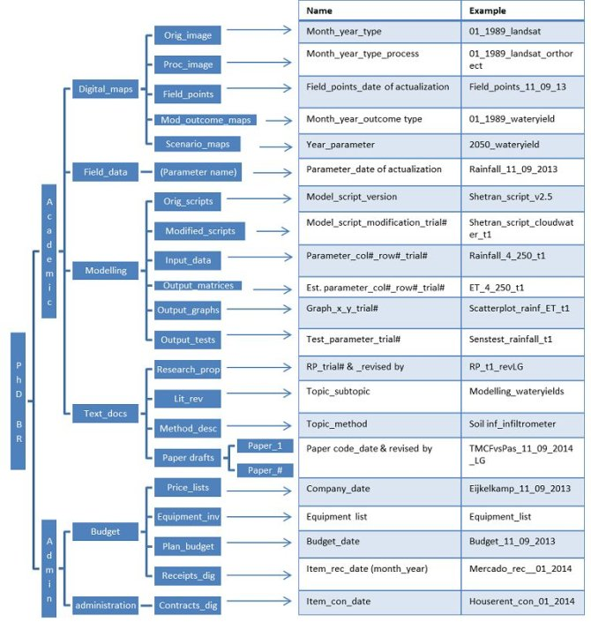
Example of a proposed folder arrangement and file naming practice for a PhD project in Earth System Science.

This Saxion DMP template is based on:
DCC. (2013). Checklist for a Data Management Plan. v.4.0. Edinburgh: Digital Curation Centre. Retrieved August 29, 2019, from http://www.dcc.ac.uk/resources/data-management-plans/checklist
Science Europe. (2018). Practical Guide to the International Alignment of Research Data Management. Retrieved May 21, 2019, from https://www.scienceeurope.org/9f7880
Wageningen University and Research (n.d.). Organising files and folders. Retrieved May 25, 2021, from https://www.wur.nl/en/Value-Creation-Cooperation/Collaborating-with-WUR-1/Organising-files-and-folders.htm

